1. Installing java on Amazon linux 2 instance on private subnet

sudo yum install -y java-1.8.0-openjdk.x86_64

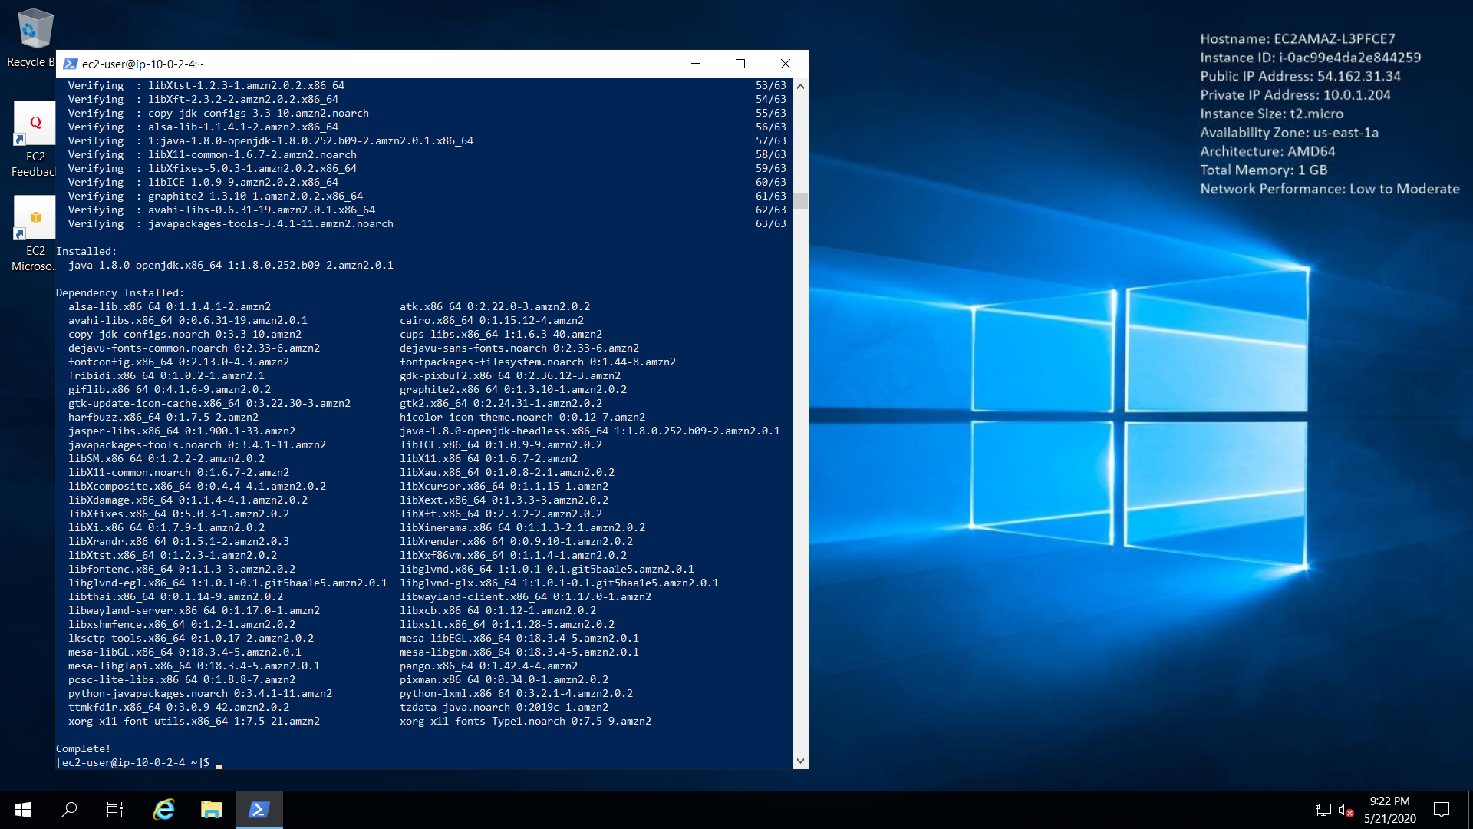

1. Installing mysql on Linux 2

sudo wget <https://dev.mysql.com/get/mysql57-community-release-el7-11.noarch.rpm>

sudo yum localinstall mysql57-community-release-el7-11.noarch.rpm

sudo yum install mysql-community-server

systemctl start mysqld.service

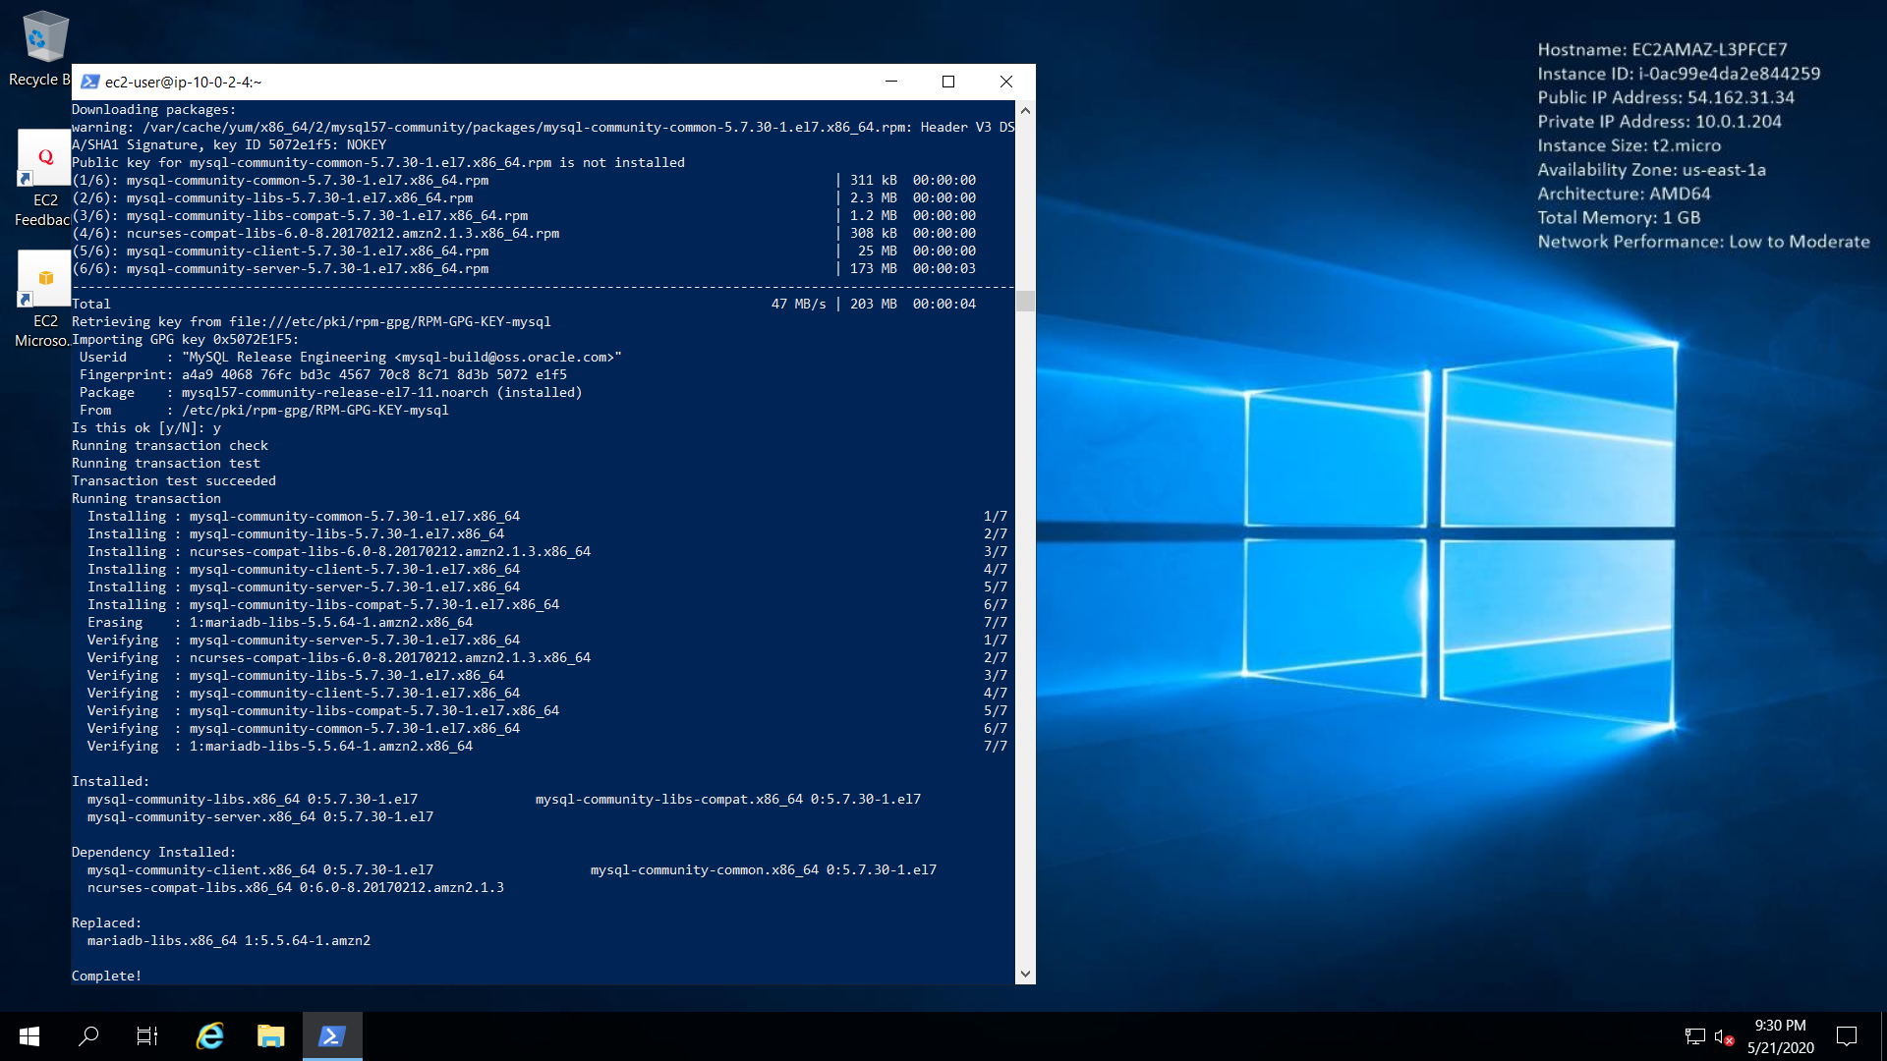

1. Installing Apache

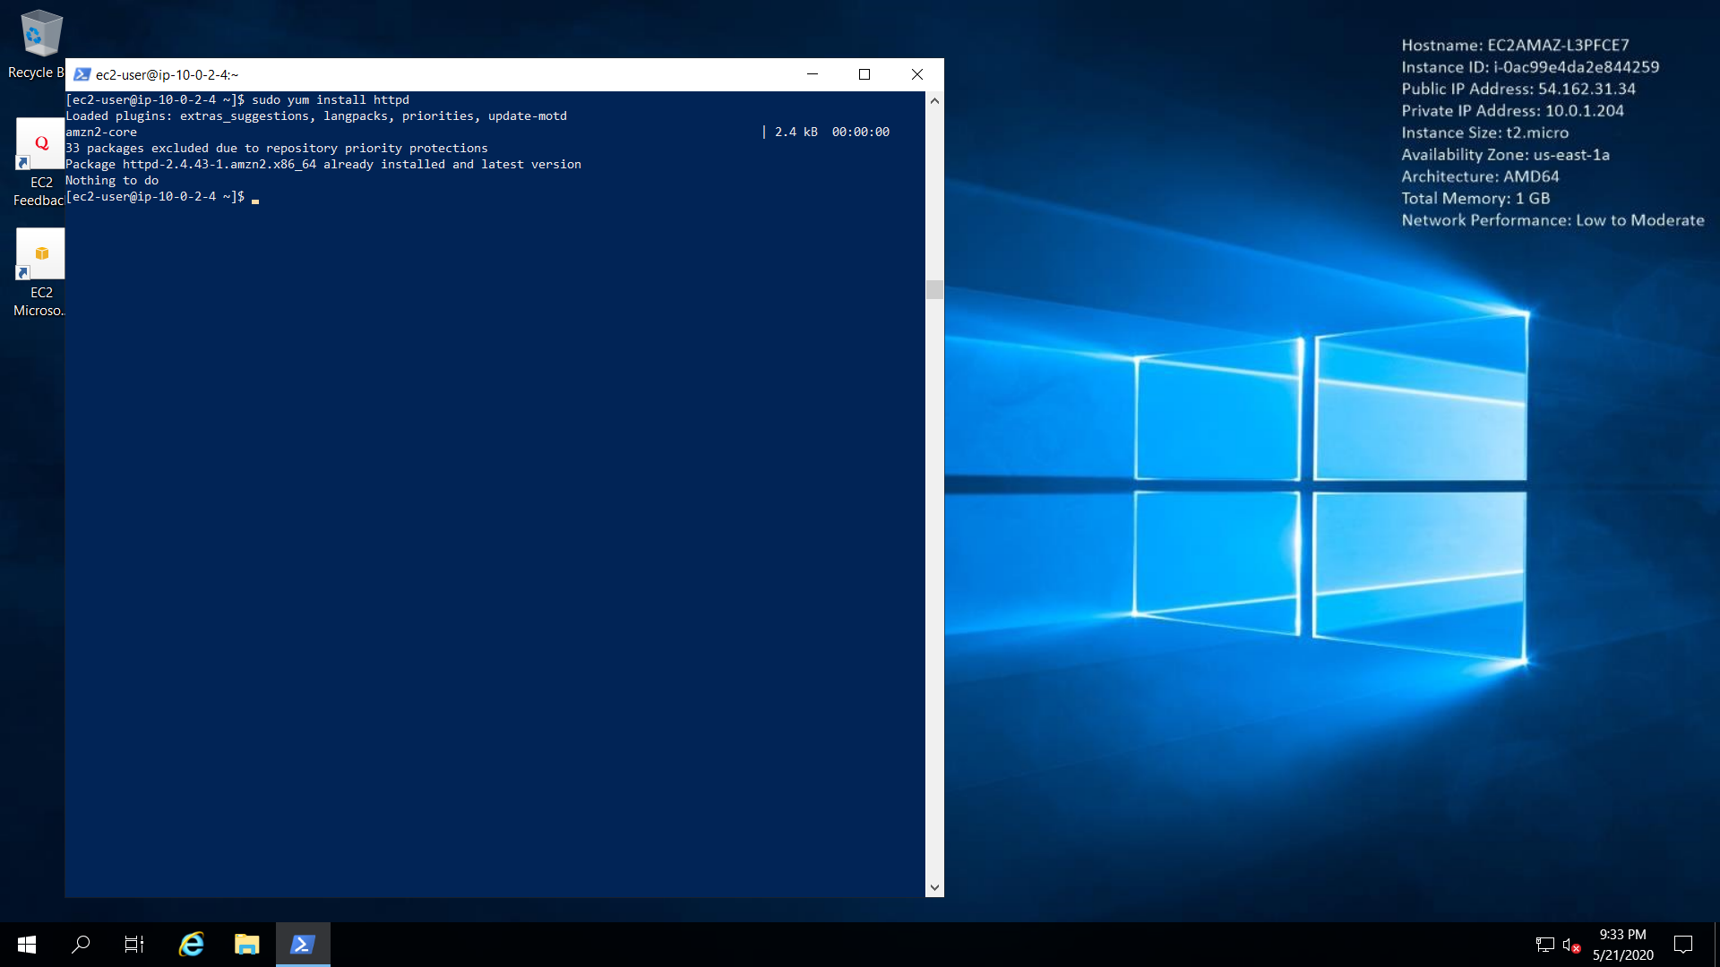

1. Installing Apache Tomcat

